UPI Transaction Analysis

Executive Report

KEY DATA DRIVEN INSIGHTS
- Fraud activity has increased sharply over time
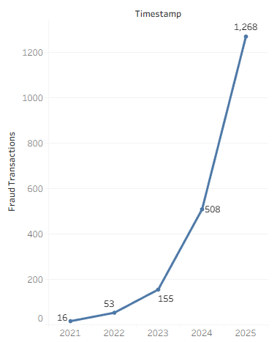
Fraudulent transactions increased from 16 in
2021 to 1,268 in 2025, indicating a substancial
increase in fraudulent activities in the most
recent period. This increase particularly
accelerated after 2023, suggesting that fraud
exposure is becoming an increasingly important
business risk and requires continuous rather
than periodic monitoring.

- Fraud accounts for 2% of all transactions
Out of 1,00,000 UPI transactions, 2,000 were identified as fraudulent, resulting in an overall fraud rate of 2%. Although fraudulent transactions are representing a very minor portion of the overall activity, the volume is significant enough to create financial, operational and customer-service consequences.

Fraud detection requires multiple behavioural signals

The fraud-alert analysis shows a very balanced distribution across the four identified alert categories: Unusual Time (507), Frequent Failure (501), Suspicious Login (498), and Unusual Amount (494). Since no single alert type dominates, dependance on one indicator alone may not be sufficient. A combination of behavioural and transaction-level signals would provide a more comprehensive basis for fraud detection and prevention.

- Fraudulent customer base
The analysis identified 1,408 customers associated with fraudulent transactions, compared with 2,000 fraudulent transactions overall. This indicates that fraud is not confined to a very small set of isolated cases, with some customers facing multiple fraudulent transactions. Hence the reinforcement of customer’s based fraud prevention, monitoring and awareness initiatives are very essential, a necessity.

- Individual high – value fraud incidents
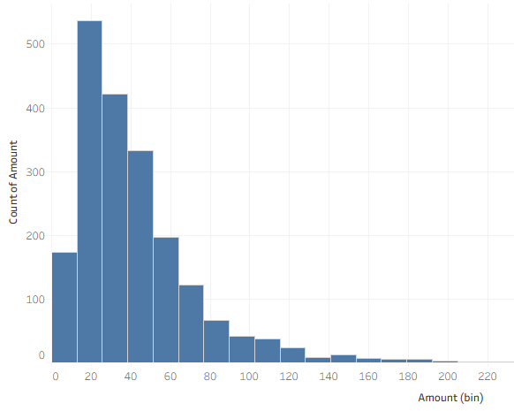
The highest fraudulent transaction recorded
was ₹373.20, followed by transactions of
₹294.33, ₹234.95, ₹234.70 and so on. This
demonstrates why fraud monitoring should
consider not only the number of incidents,
but also the value and potential financial
impact of individual transactions.

STRATEGIC RECOMMENDATIONS

- Implement continuous fraud monitoring
Combine unusual timing, frequent transaction failures, suspicious login behaviour and unusual transaction amounts into a unified risk-monitoring mechanism. This would reduce dependence on any single fraud indicator and allow suspicious activity to be identified earlier.
Metric basis: The four alert categories account for 494–507 alerts each, showing that multiple signals contribute almost equally to fraud detection.
Potential business impact: Even a 10% reduction in fraudulent transactions could potentially prevent approximately 200 incidents, based on the current baseline of 2,000 fraudulent transactions.

- Strengthen verification for high-risk and high-value transactions
Introduce additional authentication, transaction holds or customer confirmation when a transaction is unusually large or inconsistent with the registered customer behaviour.
Metric basis: The dataset contains fraudulent transactions as high as ₹373.20, demonstrating that individual incidents can carry substantially higher exposure.
Potential business impact: Beginning with almost as small as 10% reduction in the reported fraudulent amount of ₹84,713 would represent approximately ₹8,471, a good start in avoiding potential exposure.

Expand targeted customer security awareness

Develop customer education campaigns focused on suspicious login activity, unusual payment requests, repeated failed transactions and safe UPI practices. The campaign should particularly target customers who show repeated or high-risk behaviour.

Metric basis: 1,408 customers were associated with fraudulent transactions,some with repeated fraudulent transactions, demonstrating that customer-level intervention and education is relevant alongside technical controls.

Potential business impact: Reducing preventable or repeat fraud incidents can lower customer losses, investigation workload and reputational risk. The actual reduction should be measured after implementation.

The analysis identifies a 2% fraud rate across 100,000 UPI transactions, with fraud activity rising sharply in recent years. The findings highlight the need for stronger multi-signal monitoring, transaction-level controls and customer-focused prevention measures.

